
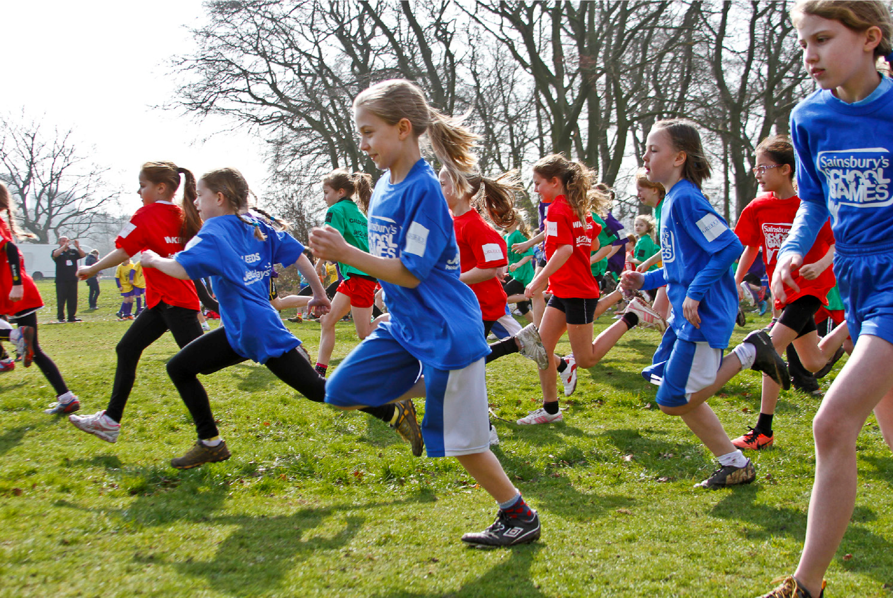

Primary Schools
Competition Rule Book
School
Sport
Partnership
Leeds

Contents

Page(s)

- Risk Assessment 3
- Health & Safety: Safeguarding 4
- Swimming – Aqua Festival 5 – 7
- Athletics (Sportshall) 8 – 18
- Basketball 19
- Cross Country 20-21
- Cricket (Kwik Cricket) 22 – 24
- DRAX Cup U9 Tournament (Cricket) 25 – 27
- Football Road to Wembley & School Champions 28
- Gymnastics (Key Step Gymnastics) 29 – 33
- Netball (High 5 Netball) 34 - 39
- Tennis (Mini Tennis) 40 - 44
- Rugby (Rugby League) 45 - 46
- Tri Golf 47 - 49
- Wake Up Shake Up 50 - 51
- Hockey (Quick Sticks) 52 - 53
- Rounders 54

The rules contained in this document are provided by the National Governing Bodies of Sport and are for the recommended level of competition for primary school age pupils. These rules are subject to change, if you are unsure about any details, please contact your SGO for further information. Any changes or updates in rules that occur after this document has been printed, will be sent out to you along with each sport competition entry form. Your local SGO will provide you with all competition details, along with a copy of your local SSP Competition Calendar.

School Games Organiser Contact Details:

Leeds North West: Natalie Mallinson n.mallinson@stmarysmenston.org

Leeds West: Charlie Pyatt c.pyatt@priesthorpe.org

Leeds North East: Chrisi Nicholson Bennett bennettc01@carrmanor.org.uk

Leeds East: Shaun Mulhern mulherns@bostonspa.leeds.sch.uk

Leeds South & Central: Helen Holdsworth hholdsworth@rodillianacademy.co.uk

Risk Assessment

It is the responsibility of individual schools to have appropriate risk assessments in place for all activities they attend. SGO’s and Active Schools will not send risk assessments direct to Schools. They should download sample risk assessments from Evolve for all Active Schools and SSP events and personalise them.

For large, centrally organised Active School events, risk assessments will be in the Active Schools tab of the resources section on Evolve. For School Games and SSP events risk assessments are in the PE tab.

The ‘Events’ risk assessment can be adapted to cover the vast majority of sites used, and for all multi skills activities. Your school may also add activity specific risk assessments if they feel it necessary. (Sample activity risk assessments can also be downloaded from Evolve.) As always a Transport risk assessment will be required.

Evolve
https://evolve.edufocus.co.uk/evco10/evchome_public.asp?domain=leedsvisits.org.uk

Health & Safety / Safeguarding
FILMING & PHOTOGRAPHY

- Please ensure that the member of staff in charge is aware of which pupils can/cannot be photographed
- Pupils who cannot be photographed must be identified by a yellow wristband which will be provided
- The school will be asked to identify a designated member of staff for photography who must wear a blue wristband which will be provided
- Only images taken by that person can be used by the school
- All persons accompanying the school must be informed of the following:
They may take photographs, however;
- they must not display or distribute images taken unless they have consent to do so from the school or Active Schools;
- they must not use images which may cause distress;
- they must not use a mobile telephone to take images;
- they must not take images “in secret” or take images in situations that may be construed as being secretive;
- they must not take images of single children/young people with no surrounding context;
- they should ensure that in all images taken children/young people are dressed appropriately
- and that any inadvertent photograph taken of a child wearing a yellow wristband must be destroyed.

FIRST AID
In the first instance staff are responsible for providing first aid to the children they have brought to the event. There will be support for larger instances. Please ensure you bring sufficient first aid supplies.
RISK ASSESSMENTS / EVOLVE NOTIFICATION
It is the responsibility of individual schools to have appropriate risk assessments in place for all activities they attend. SGO’s and Active Schools will not send risk assessments direct to Schools. They should download sample risk assessments from Evolve for all Active Schools and SSP events and personalise them.
For large, centrally organised Active School events, risk assessments will be in the Active Schools tab of the resources section on Evolve. For School Games and SSP events risk assessments are in the PE tab. The ‘Events’ risk assessment can be adapted to cover the vast majority of sites used, and for all multi skills activities. Your school may also add activity specific risk assessments if they feel it necessary. (Sample activity risk assessments can also be downloaded from Evolve.) As always a Transport risk assessment will be required.

Aqua Festival

There is no pathway, this is a fun festival with local variations.

Age Category
Children from year 4, 5 and 6 can attend and races will be in ability groups rather than year groups.

Team Requirements
- The minimum squad required to fulfil every race is 24 children (6 x non-swimmers / 6 x beginners / 6 x improvers / 6 x advanced – all determined by the distance they are able to competently swim, see below). However, if you have more children interested, you can bring up to 30 children and each child will swim fewer races. Also, if you do not have 24 children, you can still take part and simply not enter every single event.

Competition Rules and Format
- Event categories: Non-swimmers (swim aids) NON
Beginner swimmers 5-10m (Woggles) BEG
Improver swimmers 10-25m IMP
Advanced swimmers 25m+ ADV

- The more advanced swimmers will take part in a different aquatic activity in the deep end (such as mini-polo, diving or basic synchro) whilst the races are taking part in the shallow end.
- For width races, 2 / 3 children from each school will compete in each race – you will receive a full programme of events upon entry. Examples of width races include running races, egg and spoon, beach ball; all events are fun and inclusive for any ability of swimmer.
- For advanced swimmer races, 2 children from each school will compete in each race. These will include more traditional races such as breaststroke and freestyle but also fun races such as body board.
- No prior experience is required for any of the activities as full guidance will be given at the event.
- The main emphasis is on fun and enjoyment.
- Because of the inclusive element, only 4 schools can enter per event so send you entry back quickly to avoid disappointment.
- For width races, 2 / 3 children from each school will compete in each race
- For advanced swimmer races, 2 children from each school will compete in each race
- Each event will have 2 heats

Please find some information below, which may help you when selecting children for the Aqua Festival

- Non-swimmers Stages 1 & 2 (ASA Learn to Swim Framework)

Beginners Stages 3 & 4 (ASA Learn to Swim Framework)

Improvers Stages 4 & 5 (ASA Learn to Swim Framework)

Advanced Stages 6 upwards (ASA Learn to Swim Framework)

Shallow End / Width Races

Children should compete in an equal number of events where possible. No child should compete in more than 5 races. Please see below for an example of what an Aqua Festival might look like:

Event 1 NON Running Heats 1 & 2
Event 2 BEG Running Heats 1 & 2
Event 3 IMP Breaststroke Heats 1 & 2
Event 4 NON Hopping/Jumping Heats 1 & 2
Event 5 BEG Hopping/Jumping Heats 1 & 2
Event 6 IMP Front Paddle/Front crawl Heats 1 & 2
Event 7 NON Egg & Spoon Heats 1 & 2
Event 8 BEG Egg & Spoon Heats 1 & 2
Event 9 IMP Back Stroke Heats 1 & 2
Event 10 NON Beach Ball Heats 1 & 2
Event 11 BEG Beach Ball Heats 1 & 2
Event 12 IMP Breaststroke kick Heats 1 & 2
Event 13 NON Ping Pong Heats 1 & 2
Event 14 BEG Ping Pong Heats 1 & 2
Event15 IMP Front crawl kick Heats 1 & 2
Event 16 NON Swimming on front Heats 1 & 2
Event 17 BEG Swimming on front Heats 1 & 2
Event 18 IMP Back stroke kick Heats 1 & 2
Event 19 NON Swimming on Back Heats 1 & 2
Event 20 BEG Swimming on Back Heats 1 & 2
Event 21 IMP Body Board Heats 1 & 2
Event 22 NON Kicking on front Heats 1 & 2
Event 23 BEG Kicking on front Heats 1 & 2
Event 24 IMP Push & glide (2 attempts) Heats 1 & 2
Event 25 NON Kicking on back Heats 1 & 2
Event 26 BEG Kicking on back Heats 1 & 2
Event 27 IMP Walking (Bobbing under lane lines) Heats 1 & 2

Deep End

Deep End / Alternative Activities – All advanced swimmers compete in water polo or an alternative activity (e.g. diving, synchro)

25m Races

In these events, there must be 1 boy and 1 girl in each event.

Event 28 ADV Breaststroke Heats 1 & 2
Event 29 ADV Freestyle Heats 1 & 2
Event 30 ADV Backstroke Heats 1 & 2
Event 31 ADV Butterfly Heats 1 & 2
Event 32 ADV Body Board Heats 1 & 2

Event 33 ADV Water polo Heats 1 & 2

ATHLETICS
U11 Sports hall

Pathway

SSP Heat SSP Final Leeds Final West Yorkshire School Games (Cup Competition Only)

Qualification to Leeds Final: Top two schools from the SSP Cup Final.
Event Format

Team Information

School teams must consist of a minimum of 9 girls and 9 boys, with a maximum of 15 girls and 15 boys being permitted. If a team fails to meet these requirements this must be declared on the team sheet and notified at registration – the teacher in charge & SGO will note which race(s) will be discarded – no points from. Please adhere to the maximum rule as any additional athletes will not be permitted to perform. Athletes may compete in a maximum of two track and two different field events.

Please number all field competitors numbers 1, 2 & 3. Best tactics would be to try to allow each competitor a rest between their track and field events. For competitors doing 2 field events ensure they are not doing both events in the same rotation.

Additional information

Team sheets and a full explanation of each event together with teaching points have been emailed out by SGO’s and are available in the Sportshall Athletics section via the link below:
http://www.yorkshiresport.org/wp-content/uploads/2016/12/WY-Sports-Hall-Athletics-All-Info-1.pdf

At local SSP competitions, participants will have 2 or 3 attempts at the field events, dependant on time. At the Leeds Semi Finals and Final, all participants will have 3 attempts at all field events.

Staff on track and field stations. This will be allowed at ssp rounds and leeds semi final. The WY rules state staff are not allowed to be in these areas during the competition this will be enforced at the Leeds and WY finals.

Order of events

TRACK EVENTS |  | Event Number | FIELD EVENTS
No. Of Children per school | Event | Event Number | Event | No. Of Children per school
4 | Girls Obstacle Race | 1
4 | Boys Obstacle Race | 2
4 | 4 + 1 Lap Hurdles Girls Relay | 3 | Boys Competitor Number 1 | 5
4 | 4 + 1 Lap Hurdles Boys Relay | 4 | Chest Push, Long Jump, Triple Jump, | 5
 |  |  | Vertical Jump & Speed Bounce | 5
4 | 1 + 1 Lap Boys Relay | 5 | Girls Competitor Number 1 | 5
4 | 2 + 2 Lap Boys Relay | 6 | Chest Push, Long Jump, Triple Jump, | 5
 |  |  | Vertical Jump & Speed Bounce | 5
2 | 1 + 1 Lap Girls Relay | 7 | Boys Competitor Number 2 | 5
2 | 2 + 2 Lap Girls Relay | 8 | Chest Push, Long Jump, Triple Jump, | 5
2 | 2 + 2 Lap Girls Relay | 8 | Vertical Jump & Speed Bounce | 5
2 | 6 Lap Paarluf Boys * | 9 | Girls Competitor Number 2 | 5
2 | 6 Lap Paarluf Boys * | 9 | Chest Push, Long Jump, Triple Jump, | 5
2 | 6 Lap Paarluf Boys * | 9 | Vertical Jump & Speed Bounce | 5
2 | 6 Lap Paarluf Girls * | 10 | Boys Competitor Number 3 | 5
2 | 6 Lap Paarluf Girls * | 10 | Chest Push, Long Jump, Triple Jump, | 5
 |  |  | Vertical Jump & Speed Bounce | 5
4 | 4 + 1 Lap Relay Girls | 11 | Girls Competitor Number 3 | 5
4 | 4 + 1 Lap Relay Boys | 12 | Chest Push, Long Jump, Triple Jump, | 5
 |  |  | Vertical Jump & Speed Bounce | 5
 |  | 13 | Girls & Boys Competitor 1,2 & 3 | 6
 |  | 13 | Javelin | 6

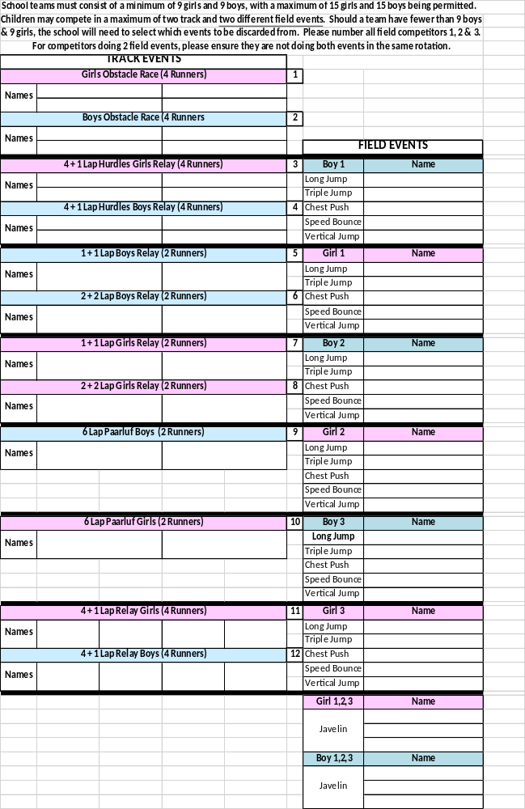
General Field Rules

Speed Bounce
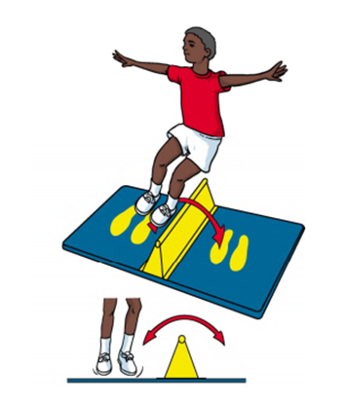
- Speed Bounce is a two-footed jump in which an athlete must take off and land on both feet – the athlete’s feet should leave the mat simultaneously and land on the mat simultaneously.
- Under 11’s (years 5 & 6) – 20 seconds
- Any bounce in which the athlete lands on or jumps around the wedge should not be counted.

Javelin
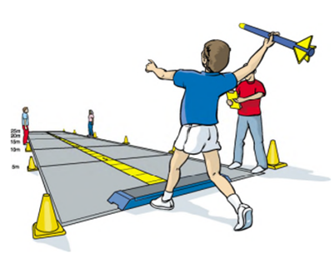
- A standing throw with a soft javelin
- Both feet behind the throwing line and in contact with the floor.
- If a foot is raised or goes over the line a no throw will be recorded.

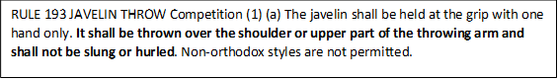

Chest Push
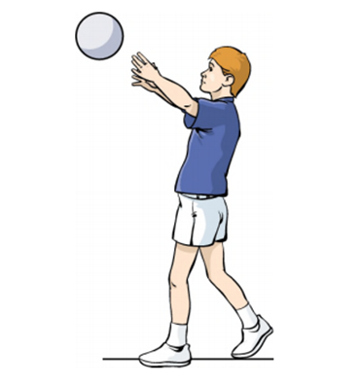
- The athlete holds the ball against their chest and pushes with both hands.
- The athlete’s chest must face forward and there must be no rotation in the trunk.
- Both feet must be behind the throwing line and remain on the floor at all times. One foot may be in front of the other but no run ups or steps are permitted.

Standing Long Jump
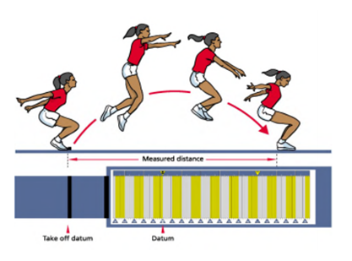
- Techniques involving a crouch or rocking motion prior to the jump are permitted provided that both feet are alongside each other and retain contact with the mat until the start of the jump.
- The athlete should jump as far as possible from a standing position, with a two footed take off. One footed take offs are not permitted.
- The athlete must land on both feet, with both feet being placed on the mat. The athlete is not required to hold the landing position and may step forward after the jump. Should the athlete step back, fall back or touch the mat or floor behind their heel, a no jump should be recorded.
- Measurement is taken from the take off line to the back of the closest heel on landing.

Standing Triple Jump
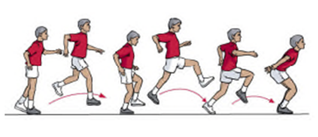
- Techniques involving a crouch or rocking motion leading up to the jump are permitted; the free leg does not have to be in contact with the mat and may be used to generate momentum by raising the knee up and down.
- The take off foot can be rocked from heel to toe as long as some part of the foot remains in contact with the mat before the start of the jump..
- A one footed take off starts the hop with the athlete landing onto the same foot, the step is taken onto the other foot after which the jump is performed by landing on both feet.
- The athlete must land on both feet, with both feet being placed on the mat.
- The athlete is not required to hold the landing position and may step forward after the jump. Should the athlete step back, fall back or touch the mat or floor behind their heel, a no jump should be recorded.
- Measurement is taken from the take off line to the back of the closest heel on landing.

Vertical Jump
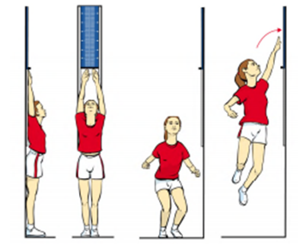
- An athlete may bend their knees and swing their arms in preparation for the event but their feet must not leave the ground until they take their jump.
- It is deemed a no jump if an athlete’s “free” hand touches the wall during the jump.

General Track Rules

The start of the track races will be as follows: On your marks - Clacker or Whistle
If for whatever reason there is a false start, a whistle will be blown twice and participants will return to the start.

Hurdles
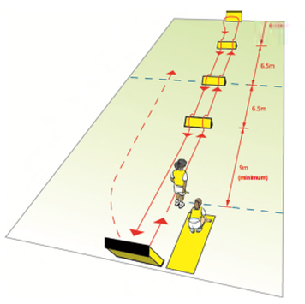
As per the new format there will be 3 hurdles in each lane. Participants must run over the hurdles, if a hurdle is missed, schools will be relegated a place in that particular race.

Relays
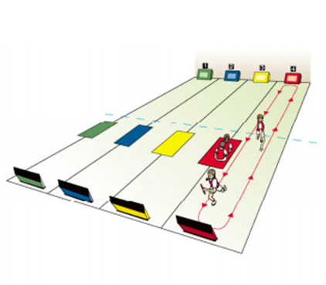
- All athletes contesting the relay sit/stand on the team base mat.
- The first athlete from each team steps up to the start line, ensuring that their feet remain behind the line. A crouched start is not permitted and hands may not be placed on the floor.
- The athletes that are not running must sit on their team mat to ensure a clear view for the judges
- In the event of a team/athlete causing an obstruction or failing to complete the relay in the prescribed format, the team may, at the discretion of the track referee, be placed in last position.

Obstacle
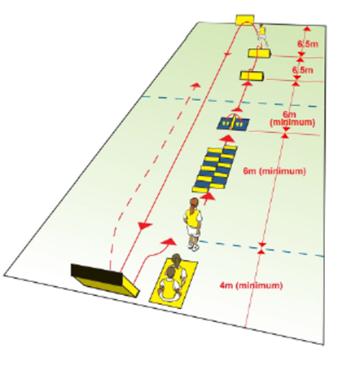
- High steppers – 10 speed bounce – 2 hurdles – use reverse board – run the return length of lane and use reverse board & change over with beanbag/baton.

Faults in the city finals

A half second time penalty is given for each fault noted. One fault will be given for each occasion an athlete:
- Misses a segment of the hi-stepper.
- Omits a bounce, e.g. an athlete who completes just seven bounces should receive three faults.
- Omits a hurdle. Faults should NOT be given if an athlete knocks over a hurdle or if it’s not been replaced.
- Passes the baton / bean bag before turning on the Reversaboard

Amendments at local level
Unfortunately at local level it may not be possible to time track events due to staffing, so the following amendments to the West Yorkshire rules will be observed. At local level there are no time penalties.
Missing a hi-stepper will mean additional speed bounces (the aim of this is to reinforce good technique for athletes through the hi-stepper at preliminary round stages).
In the event of a team / athlete causing an obstruction or failing to complete the relay in the prescribed format, the team will at the discretion of the official be relegated to last position.
In the event of the faults below occurring at the discretion of the track referee, be relegated by one place. For example the team/athlete finishing 1st will be moved to 2nd. No team should be disqualified.
Faults are awarded for-
- Omitting a speed bounce, this will occur very infrequently as a leader will count speed bounces.
- Omitting a hurdle. Faults will not be given if an athlete knocks over a hurdle or if it's not been replaced.
- Passes baton / bean bag before Reversaboard (for hurdles + obstacle races).
All faults / penalties are awarded at the discretion of the lead track judge. Apart from the amendments above all rules from West Yorkshire handbook will be followed at SSP level.

Basketball

Pathway
Cluster SSP Final

Age Category
Year 4/5

General Rules
- Each team shall consist of approx.10 team players with at least 3 of whom being girls. Five players will be on the court at any time (2 girls of which should be girls).
- Any number of substitutions can be made.
- Matches will be played on a reduced (half) sized court & Size 5/ junior balls will be used.
- Matches shall be approximately 10 minutes in duration (rolling clock)
- All team members shall wear the same colour uniforms. Bibs will be provided if not.
- The object of the game is to score more baskets than your opponents and to prevent the other team from scoring.
- The game will start with a jump ball.
- Each basket will be worth 2 pts.
- After each successful basket, the opposition shall restart the game from behind the end line.
- Please adhere to these 4 basic rules:

- Player & Ball Out of Bounds Rule
All players need to keep themselves and the ball inside the court area.

- Travelling Rule
You cannot walk or run holding the ball; so in order to move you must dribble the ball.

3. Illegal Dribble Rule
You cannot dribble with two hands at the same time or dribble again after catching the ball.

4. Personal Foul Rule
You cannot make unfair contact – a player cannot hold, push, trip or impede the progress of another player. If this is done during the act of shooting, I pt will be awarded to the team fouled.
Cross Country

Pathway
LEEDS QR –Area Comps Leeds Final West Yorkshire School Games
National.
The 1st, 2nd ,3rd, 4th placed teams in each category will qualify along with + 5 wild cards. Successful schools at the Leeds Finals will qualify for the West Yorkshire School Games.

Age Category
Years 4, 5 & 6
Format
Each school is invited to bring as many runners as they like, with a 'team' consisting of 5 runners per age group (single sex), with the first 4 runners to count towards the team score.

The race details are as follows:
Year 4 Girls Approx. distance 900 metres (First 4 runners to count towards team score)
Year 4 Boys Approx. distance 900 metres (First 4 runners to count towards team score)
Year 5 Girls Approx. distance 1500 metres (First 4 runners to count towards team score)
Year 5 Boys Approx. distance 1500 metres (First 4 runners to count towards team score)
Year 6 Girls Approx. distance 1500 metres (First 4 runners to count towards team score)
Year 6 Boys Approx. distance 1500 metres (First 4 runners to count towards team score)

This is a team competition with team entry and team qualification. A 'team' consists of five runners per event. Five individual entries are permitted per gender per age group per district for runners that do not have a team. These are classed as Wild Card entries and will be selected on a Leeds wide level taking into consideration Leeds SSP Results and Leeds Schools Cross Country Results.
Cross County Rules
Finishing positions will be added together for the team time score – the lowest score wins.
- The year 4 race is for runners in year 4 only. Year 3’s are not permitted to take part in the race and teams that are found to have year 3 runners will be disqualified.
- The year 5 race is for pupils in year 5 and the year 6 race is for pupils in year 6. Please adhere to these rules. The top 10 runners (from Yr5 & Yr6, boys and girls) will qualify for the national finals but will not be allowed to compete if you have run in the wrong age group race.
- Finishing positions will be added together for the team time score – the lowest score wins.
- This competition is restricted to 5 teams per district per event. Level 1 and Level 2 competitions vary in development around West Yorkshire and you should speak to your School Games Organiser if you have any queries about how you enter.
- There will be an opportunity, if you are running qualifiers at a district level, for 10 wildcards per gender and per age group (at a district level) to enter the Level 3 School Games. This allows up to 60 pupils per district to run as individuals. There will be individual and team recognition for the winners.

Important additional information

This year for the first time, we are using ‘chip timing’ to time the race and make scoring and placings more accurate and efficient.

Each child will be given one number with a timing tag attached. It is imperative that the tag on the back of the number is not interfered with. It is strictly one number per child.

Your team and individual runners MUST have registered by 12:45 pm regardless of their race time. Due to the complexities of this year’s timing system, if you register after this time or fail to register you will be able to run but won’t receive a time or placing.
- We will be filming the finish line of every race, due to the nature of chip timing this is an essential back up. If your child has opted out from photography and video and you are concerned about this, please contact me ahead of the event to discuss. May I assure you that this footage will be deleted after the event and will only be referred to in the event of technical failure of the chip timing (which is 99.9% effective).

CRICKET
Y5/6 Kwik Cricket
Pathway
SSP Heats Leeds Final West Yorkshire School Games

Qualifiers: The top two schools per SSP go through to the Leeds final.
Age Category
Years 5 and 6

Appendix i: Rules
- Aim
  - The enjoyment for, and fair play by, all players.
- Pitch
  - Two sets of wickets, 16 yards apart.
  - Boundaries – maximum of 35 metres apart but can be reduced to accommodate more matches.
- Teams
  - Each team comprises of 8 players. Squads are limited to 10 players.
  - Quotas pertaining to mixed sex teams have been abolished.
  - In the event of injury to a player, a substitute will be allowed to field, but not bowl. Should such an injury prevent the player batting, a substitute will be allowed to bat only with the permission of the opposing member of staff.
- The Start
  - The two teams toss a coin to decide which team has the choice of either batting or fielding first.
- The Game
  - Throughout the Tournament each game shall consist of one innings per team, each innings to be 8 overs long.
- Batting & Scoring
  - The batting side shall be divided into pairs, each pair batting for 2 overs, with a new pair starting at the end of the second, fourth and sixth overs.
  - Each team starts batting with a score of 200 runs.
  - Each time a batter is out, 5 runs are deducted and the other batter of the pair faces the next ball.
  - A batter may be out bowled, caught, run out, stumped, hit wicket.
  - There is no LBW law unless the batter deliberately blocks the ball with a leg or foot.
  - Runs will be scored in the normal way, as will byes.
  - 2 runs will be awarded to the batting team for each wide ball and no-ball bowled, but no extra ball will be allocated, except in the final over of each innings when, in addition to the 2 runs, an extra ball will be bowled. See glossary overleaf for details.
  - At the end of the first 2 overs, the first pair of batters retires and is replaced by the second pair until all 4 pairs have batted for 2 overs each.
  - The second team then bats for its 8 overs.
- Bowling and Fielding
  - Each player on the fielding side must bowl 1 over.
  - Bowling will take place from one end only.
  - Bowling should be over arm where possible.
7.3.1. At local/ district competition overarm bowling should be encouraged with the first ball of each over overarm every time. If no amount of coaching and encouragement can achieve overarm bowling, even from a base start, then the rest of the over can be bowled underarm.
7.3.2. At County/ National Finals underarm bowling is unacceptable and the ‘double bounce’ rule should be applied i.e. if the ball bounces more than ONCE, or rolls along the ground before it reaches the popping crease.
  - Players on the fielding side DO NOT need to rotate fielding positions.
  - With the exception of the wicketkeeper no fielder may field within 10 yards of the wicket, measured from the middle stump except behind the wicket on the off-side. A fielder may move into the restricted area to field a ball provided he/she was outside the area when the stroke was made.

- The Result
  - The team with the higher score wins. In the event of a tie the team taking more wickets will be the winner. If it is still equal, each player bowls 1 ball at the wickets (no batter), with the team scoring the higher number of strikes the winner.

- Eligibility
  - Please note that the tournament is open to all pupils under the age of 11 (at midnight on 31 August 2014) at State Primary and Middle Schools in England and Wales.

Appendix ii: Glossary

- An Over
10.1 An over consists of 6 balls.
- LBW
  - In the very simple terms, a batter can be given out if the umpire feels that a ball, which hits the batter’s leg, would have hit the stumps. This law will not be used unless a batter deliberately blocks or kicks the ball away with the leg or foot.

- Byes
  - If a batter misses the ball, or if it hits their body, they may still run and score byes.

- Wide ball
  - A ball that is too far from the batter to strike will be called a wide. A ball will not be called a wide, no matter how wayward it may be, if the batter manages to hit it.
  - If a ball results in more than 2 wides, they will be added to the batting team’s score and the two runs for the wide will be ignored. For example, a bowler delivers a ball so wide it is missed by the wicketkeeper and crosses the boundary for 4. 4 runs are given to the batting side, not 6.
- No ball
  - If a ball bounces more than once before reaching the batsman, of if it reaches the batsman above shoulder height without bouncing, it will be called a no ball.
  - A batsman may hit a no ball and if the shot results in 3 of more runs being scored, that score will count and the 2 runs for the no ball will be ignored. If 1 or 2 runs are scored the batsman will be credited for the 2 runs for the no ball.

Appendix v: Rules for Indoor Competitions

Normal Rules will apply except:
- No bowlers many bowl more than 2 overs.
- Bowling will be from one end only.
- Ball striking the side walls/behind wall first will gain 1 bonus to be added to the score.
- Ball Striking back wall (boundary wall) first after having bounced will gain 4 runs to be added to the score and will be counted as a boundary.
- Ball striking back wall (boundary wall) first without striking the floor will gain 6 bonus runs to be added to the score and be counted as a boundary.
- Should batters complete a single by running, this will count as runs to be added on to any bonus run. As in normal cricket, runs cannot be added to boundaries.
- No runs scored for hitting the roof but players can still run.
Dismissals: As in normal cricket, but with the following additions:
- A batter may be caught out one or two handed off a side wall, the wall behind the wicket keeper or the roof, provided that the ball has not already bounced or struck the boundary wall. Any bonus runs from striking the wall shall not count.
- A ball which strikes the boundary wall after having struck a side wall or the roof may be caught, resulting in a dismissal.
Cricket
U9 Drax Cup
Pathway
LEEDS Active Schools City Wide West Yorkshire Final Yorkshire Final

Age Category
Under 9’s
2015 Rules and Regulations
The Drax Cup is a mixed sex competition. Teams must include two members of
the opposite sex at all stages of the competition. See rule 1.6 for further details.
1. Competition Procedure
1.1 Schools entering a team in the U9 age group shall be invited to compete for the
"Drax Cup" competition, which is organised on a ‘cluster festival’ basis. Schools unable to be included in a cluster may be entered as a team in a knock-out stage.

1.2 The competition will begin week commencing 20 April 2015. All local events to be completed by Friday 12 June 2015. Area Finals to be completed by Friday 3 July 2015.

1.3 All arrangements for the Finals Day will be made by the Executive Committee, including selection of ground and the appointment of neutral umpires.

1.4 In the event of no play or a tie in any knock-out stage, Playing Regulations 3.2 or 3.3 or 3.4 shall apply.

1.5 All players must be under 9 years of age at midnight on 31st August 2014 i.e. School
Year 4 pupils, and may only play for one school in the competition.

1.6 A team must include at least two members of the opposite sex with the exception of those teams provided by single sex schools. Failure to follow this rule will result in the school not being able to proceed to the next round of the competition.

1.7 A school may only enter the competition through one school sports partnership event. Entries into multiple partnership events are not allowed. A school may enter more than one team into an event and if so must clearly state “Team A” and “Team B” when registering.

1.8 The SGO has the primary responsibility for organising the date of the festival and must notify the schools as to the club or school ground at which the fixture will be played. This includes directions or whether a playground or grass facility is being utilised. This must happen at least 24 hours before the match. At any knock-out stage this is the responsibility of the home side or host SGO.

1.9 It is a requirement that the results and schools taking part are emailed to draxcup@yorkshirecb.com no later than 8pm of the round completion date.

1.10 For the Final, schools are required to nominate a squad of ten players by email to
Ross Atkinson, competition lead r.atkinson@yorkshirecb.com no later than the Monday prior to the date of the Final.

1.11 Medals will be presented to the losing side in the Area Finals and to all four teams who participate in the Final.

2. Playing Regulations
  - Play in the Cup Round stage of competition to commence at a time mutually agreed by schools or the organising body.

  - The pitches shall measure 16 yards in length. Boundaries shall be set at a maximum distance of 25 yards from middle stump.

  - The ball shall be of junior ‘Windball’ (soft) specification (there is no requirement for helmets to be worn).

  - A match is to be one innings per side with each innings being 8 x 6 ball overs.

2.5 Each side is to consist of eight players. A match is still valid if a team comprises of only seven players, provided the opposing team manager selects the player who will complete the fourth pairing.

2.6 Each batting side will start their innings with a score of 100 runs.

2.7 The batting side shall be divided into pairs, each batting two (2) overs. The "pairs" shall be changed at the end of the second, fourth and sixth overs.

2.8 Batsmen shall have unlimited "lives" but each fall of wicket shall result in five (5) runs being deducted from the total. They shall change ends at the fall of each wicket.

2.9 Bowling shall be from one end throughout the match. Each bowler shall bowl one over. The bowler shall be changed at the end of each over. Each batsman shall receive three (3) balls of each over delivered.

2.10 Bowling shall be either ‘under arm’ or ‘over arm’ at each players discretion.

2.11 No fielder to be allowed within 10 yards of the striker until the ball is played. Fielders to rotate clockwise after each over so that all players get a turn in each fielding position, including acting as wicket keeper (note: no gloves required).

2.12 Dismissals to be restricted to five methods namely, bowled, caught, run out, stumped and hit wicket. Appeals for LBW to be declined (unless the batter has deliberately stopped the ball from hitting the stumps).

2.13 The striker, in the stance position, must not be allowed to obscure the view of "off stump" in readiness to receive a delivery. A "middle” guard to be given.

2.14 The bowler shall be penalised for a "no ball" when the delivery bounces three or more times/rolls along the ground, before reaching the striker, OR if the ball passes the striker above waist height when standing in an upright position. Bowlers are to be encouraged to bowl within the crease markings and only where there is persistent overstepping, and after at least two warnings noted by both umpires, should a bowler be noballed for over-stepping.

2.15 "Wide ball" is only applicable when the delivery is clearly out of the striker's reach.

2.16 The batting side shall be awarded two (2) penalty runs for a "wide ball" or "no ball" delivery. The ball to count as one of the over and an extra delivery is not allowed EXCEPT in the final over of each innings where two runs will be added to the score and the batsman shall receive an extra ball.

3. The Result
3.1 The winning team shall be the side scoring the higher number of runs after deductions for the fall of wickets (recorded as the "net total").

3.2 If any match in the competition ends in a "tie" the team losing the least wickets will be declared the winner. Failing this, a "bowl out" contest shall be arranged between players from each side. Each team shall select three bowlers to bowl three deliveries and the winner shall be the team scoring most hits from a maximum nine attempts. If still equal a round of "sudden death" bowling from other bowlers will follow until a winner is established, with a toss of a coin deciding which team shall bowl first.

3.3 Any Cup Round at any knock-out stage, which is abandoned or is not started due to fitness of ground, weather or light, shall be re-arranged on the earliest date available as agreed by both sides. An incomplete match is invalid and the match shall be re-played.

3.4 In the event of outdoor play being impossible due to weather conditions and of a match that cannot be re-arranged within the round completion date, the match may be staged indoors. Failing that a bowl out under Rule 3.2 shall apply. Failing all other attempts the tie will be decided by the toss of a coin.

Further Information

https://yorkshireccc.com/draxcup

Leeds United Foundation: Road to Wembley U’11s
& School Champions U’9s

Pathway
SSP Heats - City Finals - Championship Finals Day – Championship North Regional Finals

Full competition details have been emailed out via SGO’s and are also available on the SSP websites in the primary entry forms section.

Entry Requirements U9’s

- Maximum 2 members of staff
- Years 3 & 4
- Minimum 7 players, maximum 10 players
- 3 players must be female
- 1 female player must always be playing

Entry Requirements U11’s

- Maximum 2 members of staff

Year 5 & 6
- Minimum 7 players, maximum 8 players
- Mixed teams of boys and girls is encouraged

Prizes
All players to receive match tickets to a Leeds United home game.

Further Information
Email: Michael.kinsey@leedsunitedfoundation.com
Tel: 0113 3676341

Gymnastics
Key Step Gymnastics

Pathway
Leeds Competition West Yorkshire School Games

Age Categories
Teams will consist of 5 pupils, please bring participants from the following age categories:
- Level 2 – Y3&4 Advanced and Foundation
- Level 3 – Y5&6 Advanced and Foundation
Team & squad numbers: | Teams of 5 with the top 4 scores to count
Level 3 qualification: | Top team per district per competition
Further information: | www.british-gymnastics.org

Team Eligibility
In order to provide all young people across West Yorkshire the opportunity to represent their school and district at a county schools competition whilst still keeping the competition fair there will be 2 levels of competition for the primary schools.

Foundation Level
Young people in the foundation level must not participate in gymnastics training for more than 2 hours per week. All young people in the team must fit these criteria for the team to be entered in the foundation level

Advanced Level
Any young person can enter the advanced level regardless of the number of hours a week they train in gymnastics. If the team has at least 1 gymnast who fits these criteria then the team must be entered into the advanced level
The age groups remain the same so there will be a foundation and advanced level competition for year 3/4 and year 5/6. The routines remain the same and are the same for both levels.

Selection
Key Stage 2 Year 3/4 – Foundation Level – 1 team per district
Key Stage 2 Year 3/4 – Advanced Level - 1 team per district
Key Stage 2 Year 5/6 – Foundation Level – 1 team per district
Key Stage 2 Year 5/6 – Advanced Level - 1 team per district
Selection will be made from a preliminary competition in the individual Local Authorities to take place prior to the WYSG.

Dress
Pupils may wear leotards or shorts and T-shirts. All jewellery must be removed and hair must be tied back.

Key Stage 2 Year 3/4 - Foundation and Advanced

Team Requirements
5 pupils will compete on each piece of apparatus, with the 4 best scores to count.
Participants will compete as a team, consisting of a mixture of boys and girls. (N.B. single sex teams are also allowed, however mixed teams are preferred).

Competition Format
Following the National Framework for Gymnastics the Key Stage 2 Competition will follow the Key Step 2 Gymnastics Criteria.

Floor level 2
- Step forwards, bring feet together, forward roll to stand
- Step hop, step hop, step forwards into arabesque
- Bring feet together, 180° jump
- Backward roll to kneel
- Front support position, one press up
- Turn through side support into back support
- sit, shoulder stand, roll to stand
- Quarter turn and cartwheel

Vault Level 2
Perform 2 vaults. The same vault can be performed twice or one of each:
- Squat onto vault lengthways, stand up, walk to end, stretch jump off
- Squat onto vault lengthways, stand up, walk to end, tuck jump off
N.B Level 2 vaults may be performed with or without a springboard and may use a vaulting box or trestle table.
There are no extra marks for the use of a springboard. The quality of the vault and the control the gymnast has on the apparatus are the most important factors with regard to judging. It may be better for some gymnasts to perform the vault without the use of a springboard so that better control and tension can be maintained throughout the vault resulting in a higher score than would be achieved performing a vault using the springboard but having less control.

Body Management Routines – Level 2
- 5 x bounces with a skipping rope
- Lay down, Dish shape with 1 leg extended at a time
- Sit up and press towards ½ lever
- Straddle legs and lean towards Japana fold (back must be flat)
- Lay down, roll over and lift into Arch
- Show front support and lower to floor
- Kneel up and show splits position all 3 ways (as low as ability allows)
- Shoulder flexibility
- Stand up, standing broad jump
Each team will be given 20 minutes for general warm up. Each team will also be given a short practice on each station before the competition commences.

Key Stage 2 Year 5/6 – Foundation and Advanced

Team Requirements
5 pupils will compete on each piece of apparatus, with the 4 best scores to count.
Participants will compete as a team, consisting of a mixture of boys and girls. (N.B. single sex teams are also allowed, however mixed teams are preferred).

Competition Format
Following the National Framework for Gymnastics the Key Stage 2 Competition will follow the Key Step 3 Gymnastics Criteria.

Floor level 3
The floor routine will be performed along a strip of mats as in key step 2.
Participants must perform the following six moves
- Round off OR Fast cartwheel (starting facing forward and landing facing backwards 1 foot at a time joining second foot to first foot)
- Side scale balance (towards Y balance or if preferred full Y balance, but this doesn’t get any more marks)
- Backward roll to straddle
- Half turn stretch jump OR full turn stretch jump
- Two consecutive cartwheels OR Handstand forward roll
- Bridge (return to the floor) OR Splits OR Half lever (not full lever)

The skills can be performed in any order
Linking moves can be used between the skills to help make the routine more fluent however these linking moves will not be marked.

Vault Level 3
Perform 2 vaults. The same vault can be performed twice or one of each:
- Squat onto vault width ways, stretch jump off
- Through vault
N.B Level 3 vaults may be performed with or without a springboard and may use a vaulting box or trestle table.
It is not recommended to perform the through vault on a trestle table
There are no extra marks for the use of a springboard. The quality of the vault and the control the gymnast has on the apparatus are the most important factors with regard to judging. It may be better for some gymnasts to perform the vault without the use of a springboard so that better control and tension can be maintained throughout the vault resulting in a higher score than would be achieved performing a vault using the springboard but having less control.

Body Management Routines – Level 3
- 10 x bounces with a skipping rope
- Lay down, Dish shape
- Roll over into arch shape and back into dish shape
- Sit up and press towards ½ lever lifting 1 leg off and then the other.
- Straddle legs and Japana fold (back must be flat)
- Push to back support, turn into front support, lower to floor and push back up again
- Show right leg splits, box splits then left leg splits (in an upright position)
- Lay flat and push to bridge (head must be off the floor)
- Rock backward and forwards to stand, standing broad jump
Each team will be given 15 minutes for general warm up. Each team will also be given a short practice on each station before the competition commences.
General information
There is a Key Step Gymnastics Support Pack available to support the delivery of the key step routines and gymnastics within schools. To access this pack schools can register with British Gymnastics to become a Partner School for an annual fee of £16.00. This will provide access to a secure downloads section of the website. Here you will have access to a variety of toolkits and documents, which will support you through the development of curricular and extra-curricular gymnastics. Registering as a BG Partner School will also give you access to support from a BG Development Officer.

To register you will need to visit the BG website: www.british-gymnastics.org to complete an online registration form. You will need to know the approximate numbers of pupils engaged in gymnastics in your school. You will be provided a user name and password which will give you access to the schools downloads section of the website.

Examples of support documents include:-
- An interactive pathway of competitions available to pupils including information and advice on criteria and how to prepare pupils
- After School Session Starter Pack
- Club to School Link toolkit
- Downloadable resources including Key Step and Next Step
- Termly E-newsletters

British Gymnastics have a range of teacher’s courses, which can support the delivery of gymnastics in schools. Information on these courses can be found at www.british-gymnastics.org
Each team will be given 15 minutes for general warm up. Each team will also be given a short practice on each station before the competition commences.

Staffing
Schools are requested to bring a minimum of one qualified coach /teacher and additional helpers who are registered with their schools. They should not assist with pupils from other schools. We strongly advise there is a teacher / helper / coach - pupil ratio of 1:10., and that they must have enough helpers / staff to directly supervise their pupils in each category.

Each team will be given 10 minutes for general warm up. Each team will also be given a short practice on each station before the competition commences.

There is a Key Steps Support Pack that is available for schools to buy which will support the delivery of the key steps routines and also the delivery of gymnastics within the curriculum.

NETBALL

High 5

Pathway
Pathway
SSP QR Area Final Leeds Final West Yorkshire School Games

Qualifiers: Two schools per area go through to the Leeds final.
Age Category
Year 5 and 6

Further Information: https://www.englandnetball.co.uk/high5/

RULES
See the England Netball website (link above) for full rules, resources and rotations.
1. Please note the following differences between High Five and the full 7 a-side Adult Rules:
- “A player must pass or shoot within FOUR seconds” (Rule 6a, page 8)

- “Defending the ball in a player’s hands by outstretching the arms is not permitted. The player with the ball must be permitted an unimpeded throwing or shooting action. ONE JUMP to intercept a throw or shot at goal is permitted provided that the player is AT LEAST 1m away and that the arms are not outstretched prior to the jump. Jumping up and down in front of the player is not permitted” (Rule 9, page 10)
The game will be played on a full size court, or scaled down version as space dictates, with a Size 4 Netball. The ring will be 9 feet from the ground.

Players must be Under 11 (academic years 5/6)
A minimum of SEVEN and a maximum of NINE players can be used in the competition. All players must play and take part in the rotation procedure. (see attached rotation sheets)
Note: Squad of 7 a minimum of 4 girls; Squad of 8 or 9 minimum of 5 girls
Players will rotate as per the rotation table. Please ensure that they do so quickly to avoid long time delays both during and between matches.
Note: It is important that players learn about the responsibilities attached to each position on the court and also are not ‘stereotyped’ in one position because, for example, they are tall or very fast. The changes made during the playing period will move shooters to defence or centre court and vice versa.
Note: Scorers/Timekeepers and Centre Pass Markers will work with the tournament desk when undertaking this roles.
Teams will need a set of bibs with playing positions GK, GD, C, GA & GS.
Note: a spare set of bibs, in a different colour would be advantageous in case of a colour clash with another team.
Please ensure that each team is ready to go onto the court at the start of each match and that each player knows which position they are starting in and changing to at half-time
Matches will be 2 x 6 minutes each way. There will be 2 minutes at half time and 3 minute between matches.
Umpires will be provided at the Leeds Final and West Yorkshire School Games. Teachers may be asked
to umpire their own games at local SSP level

Points will be awarded as follows:
5 points for a win
3 points for a draw
1 point for losing team scoring more than 50% of the goals scored by the winning team
i.e. 6-4 = 1point; 6-3 = 0points

The score sheet is to be handed into the score table at the end of the game.
Start of Play: Team Captains toss a coin to determine who takes the first Centre Pass. Subsequent centre passes must be taken alternately. Play is started by a pass from the ‘Centre’, who stands with both feet in the centre circle.
At the start of play the GS, GA, GD and GK may be anywhere in the goal third. The opposing Centre shall be in the centre third and free to move.
When the umpire blows the whistle, the Centre must pass the ball within 4 seconds and obey the Footwork rule. The ball must be caught or touched in the centre third.
13. Playing the Ball: A player must:
- Pass or shoot within 4 seconds;
- Obey the footwork rule;
A player may not:
- Deliberately kick the ball;
- Bounce the ball more than once;
- Hand or roll the ball to another player;
- Place their own hands on a ball held by an opponent;
- Throw the ball while sitting/lying on the ground;
- Use the goalpost as a support in receiving a ball going out of court or to gain balance;
- Throw the ball over a complete third without it being touched or caught by another player in that third;
- Regain possession of the ball, having dropped or thrown it, before it has been touched by another player.
Penalty: Free Pass.
14. Footwork Rule:
- A player may receive the ball with one foot grounded or may jump to catch the land on one foot. While that landing foot remains on the ground the other foot may be moved in any direction and any number of times, pivoting on the landing foot if desired. Hopping is not allowed;
- A player may receive the ball whilst both feet are grounded, or may jump to catch and land on both feet simultaneously. The player may then chose to move either foot and the remaining foot shall then be considered to be the landing foot. Proceed as in a) above.
Penalty: Free Pass.
Scoring a Goal: A goal may only be scored by the Goal Shooter or the Goal Attack from within
the shooting circle.

Obstruction: The player with the ball must be permitted an unimpeded throwing or shooting action. One jump to intercept a throw or shot at goal is permitted provided that the player is at least 1m away and that the arms are not outstretched prior to the jump. Jumping up and down in front of a player is not permitted.
Penalty: Penalty Pass or Shot
Contact: No player shall knock or push an opponent or interfere with his/her play, either accidentally or deliberately.
Penalty: Penalty Pass or Shot
Out of Court: A ball is out of court when it, or a player touching it, touches the ground or an object outside the court. The line counts as part of the court. If the ball hits the post and bounces back into court, it is still in play.

The Throw-in: The throw-in is taken at the point where the ball crossed the line. Any player allowed in that part of the court may take the throw-in and must stand outside the court with both feet behind the line. When the player taking the throw-in has checked that all other players are on court, she/he must release the ball within 4 seconds.

Offside: A player is offside if she/he enters an area of the court in which she/he is not allowed.
Penalty: Free Pass
Penalties: Free Pass/Penalty Pass or Shot A free pass is awarded to a team for any infringement of the rules except obstruction and contact. A player may not shoot directly from a free pass. A penalty pass or shot is awarded to a team against any player causing obstruction or contact. A player may shoot if the penalty is awarded inside the circle. The offending player must stand still beside the player taking the pass. Penalties: Free Pass/Penalty Pass or Shot A free pass is awarded to a team for any infringement of the rules except obstruction and contact. A player may not shoot directly from a free pass. A penalty pass or shot is awarded to a team against any player causing obstruction or contact. A player may shoot if the penalty is awarded inside the circle. The offending player must stand still beside the player taking the pass.

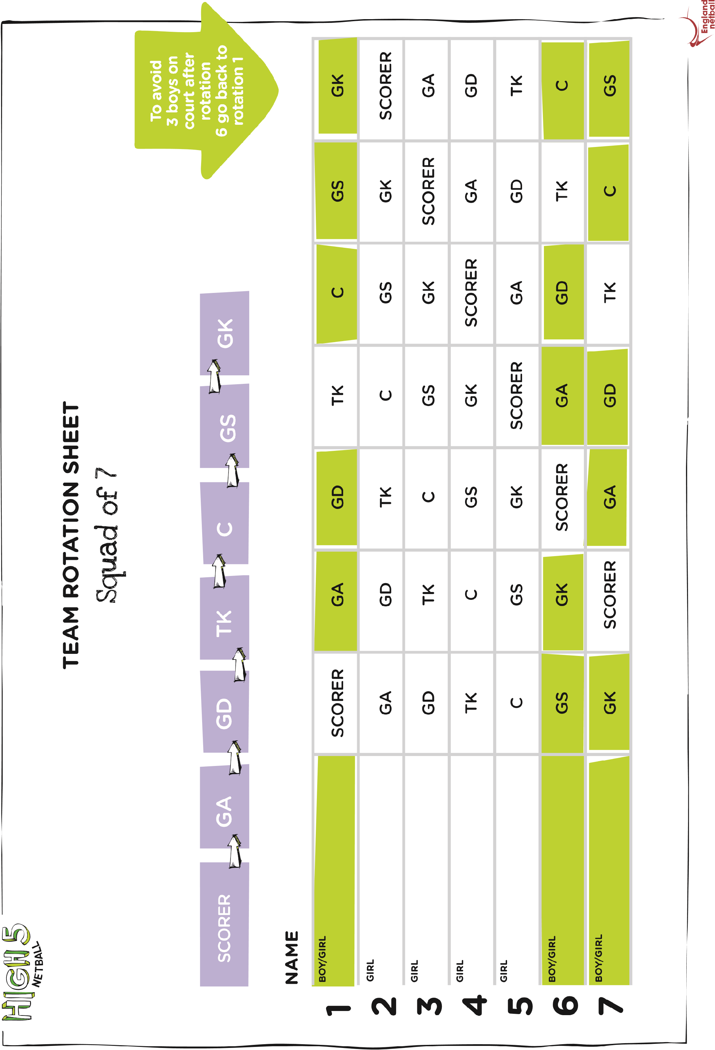
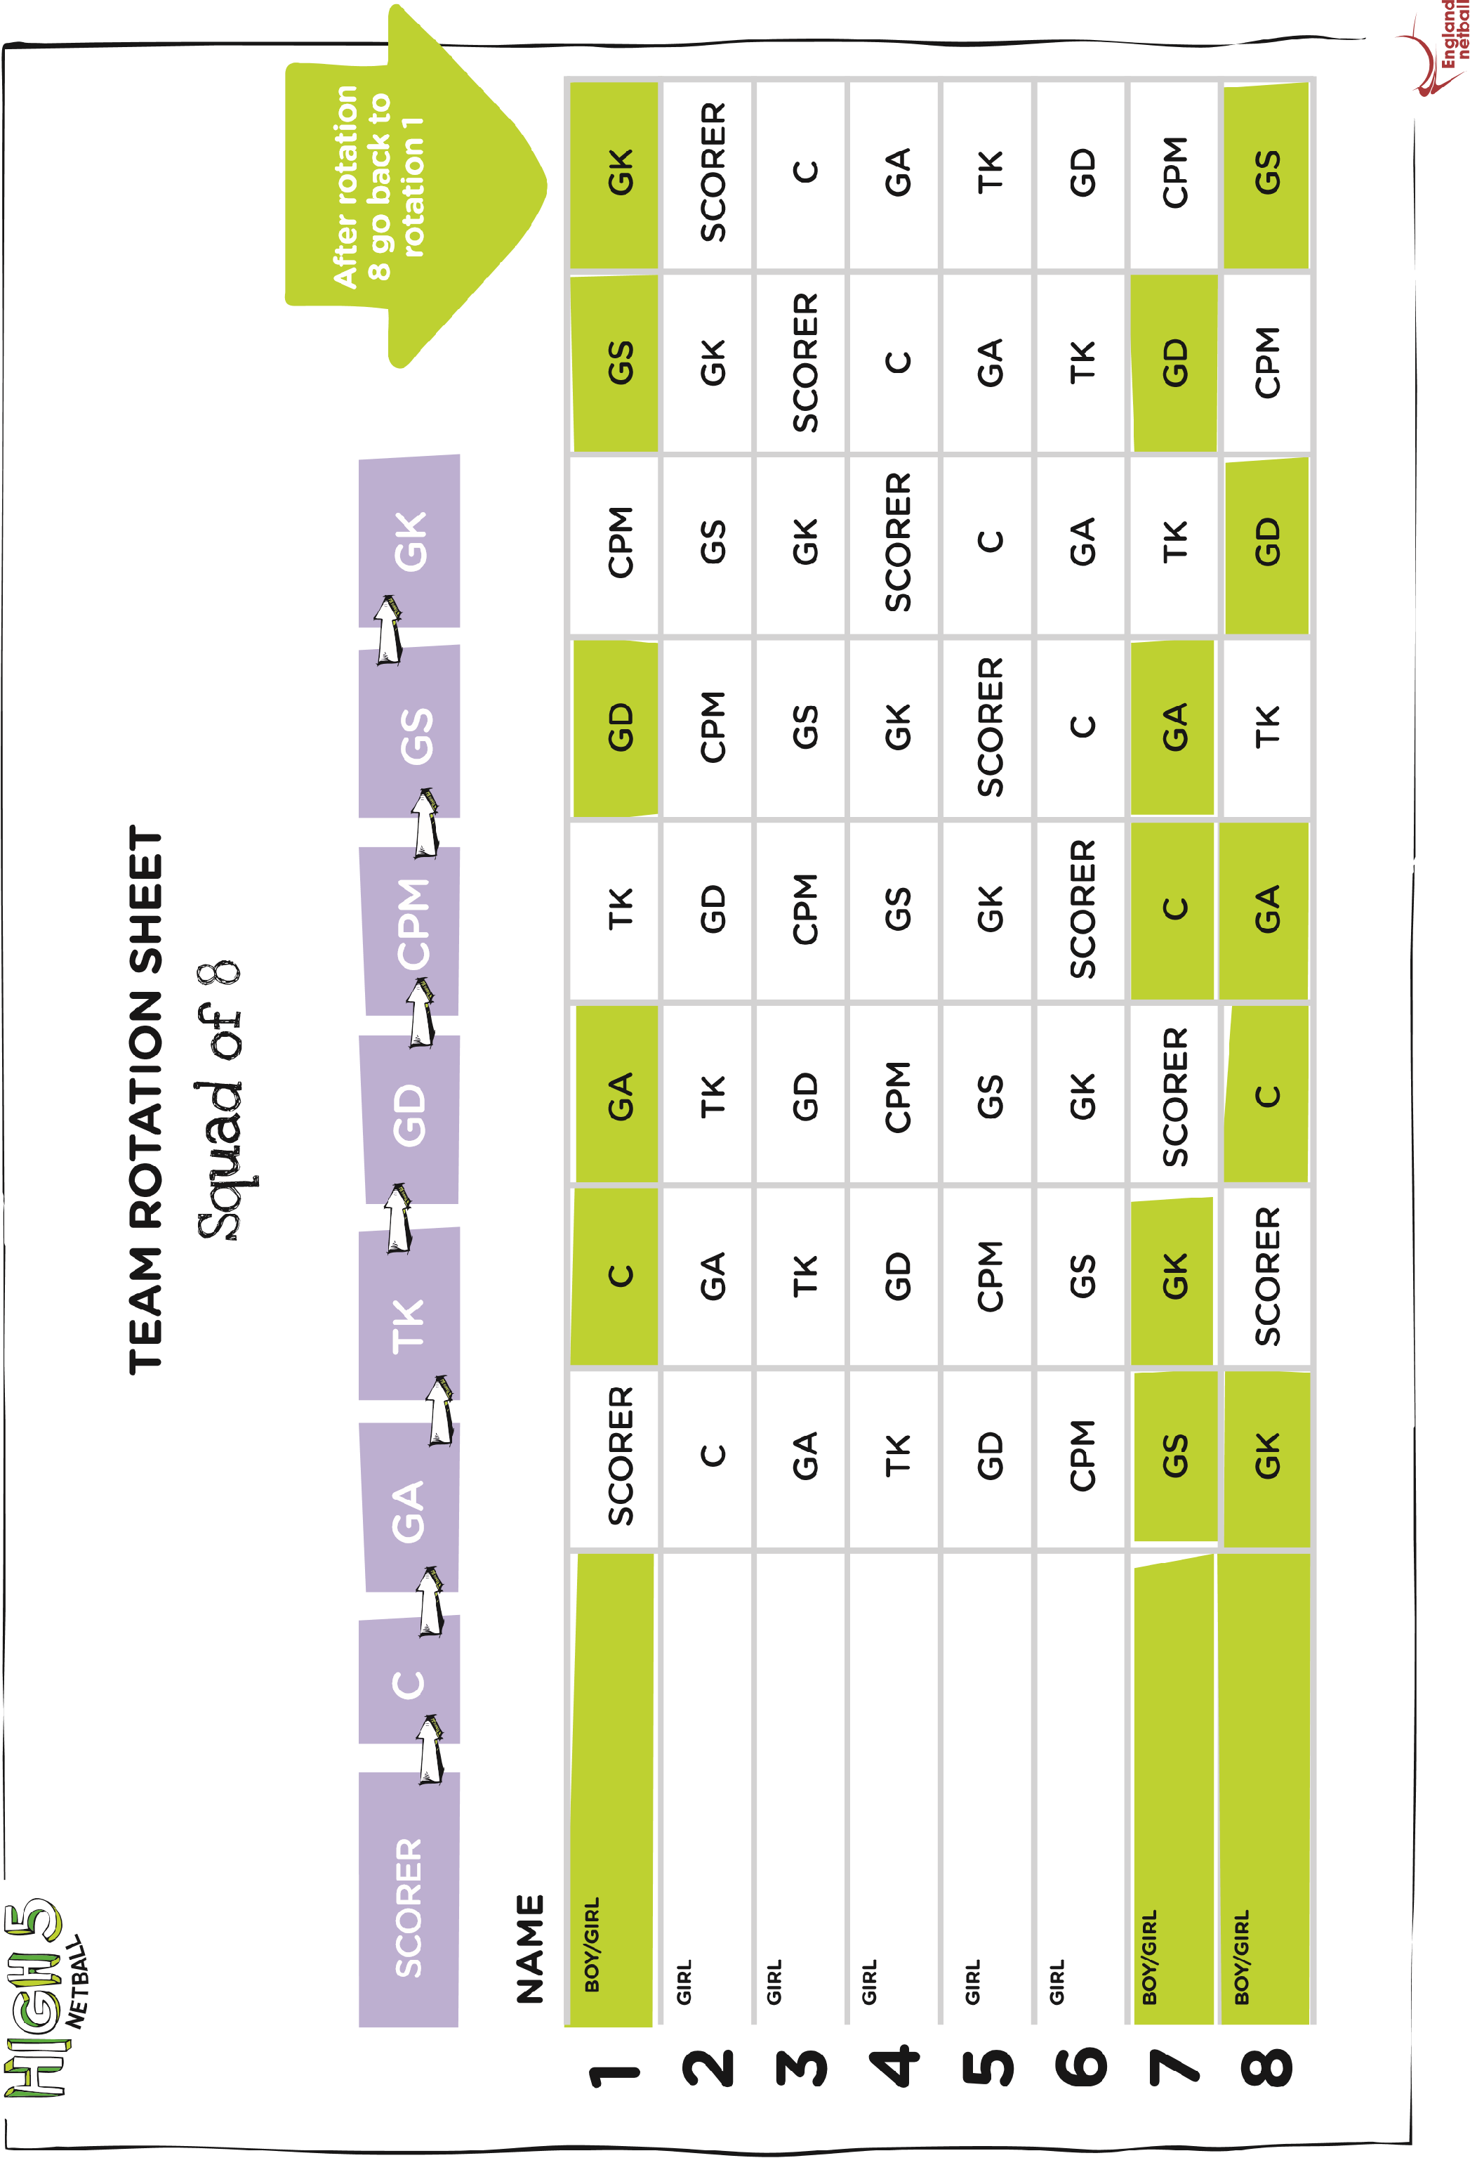
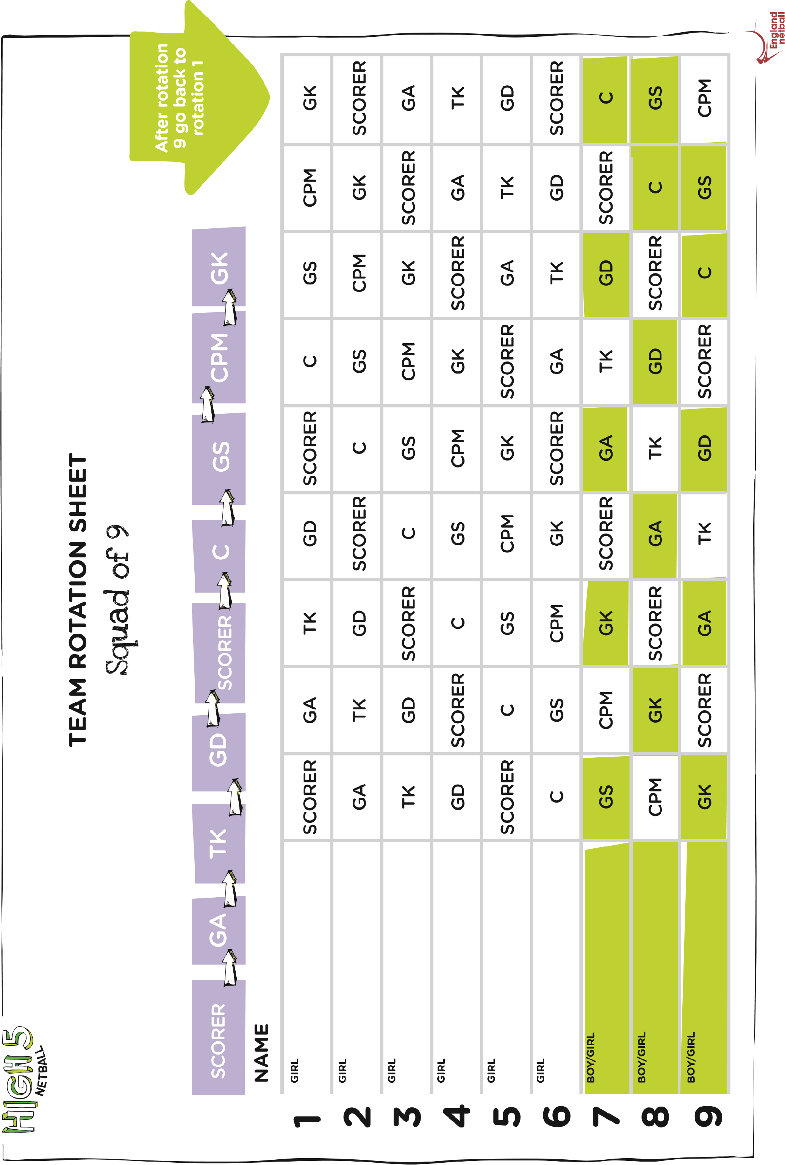
MINI TENNIS
Pathway
SSP QR Area Final Leeds Final West Yorkshire School Games

Qualifiers: Two year 3/4 teams and two year five teams per SSP.
WYSG Finals Tennis: Y3/4 Mini-Tennis Red.
Event: | Y3/4 Mini-Tennis Red
Age group(s): | Y3/4
Team & squad numbers: | 4x players per team – 2x boys (1&2) and 2x girls (3&4)
Level 3 qualification: | Top TWO teams per district
Format: | Round robin group format followed by play-offs (if needed) to determine final team positions.
Singles match order: | - Round 1: Singles 1v1, 2v2, 3v3, 4v4  - Round 2: Reverse Singles 1v2, 2v1, 3v4, 4v3  The reverse singles is subject to format eg A large RR of 10 teams for Y3/4 would not require reverse singles as each player would get 9 individual singles matches (6-10 matches for Red is the norm)
Seeding: | There should be no pre-seeding of teams for the group stage other than team optimisation (where possible) to avoid teams from the same area playing each other at the group stage.
Courts: | Mini Red Courts on Indoor Tennis Hall  
Balls: | Indoor Mini Red Sponge Balls 
Rackets: | No larger than 23’’ Mini Rackets, 21’’ are fine.
Scoring: | - Each rubber is first to 10 points, next point wins at 9-9 (Match Tie-break)  - The first server serves one point from the right and then it is 2 points per player thereafter alternating points serving from the Left and Right.  - Players stay at the same end of the court for the entire match.
Serving: | - Serves are diagonal into the service box from behind the baseline.  - A player receives a 2nd serve in the event of the first serve being out or in the net. 2 errors is a double fault and a lost point.  - Serves can be over-arm or under-arm (There is no rule in tennis to say the serve must be over-arm, only that the ball must be played before it bounces.)  - A ‘let’ is played if the ball touches the net on the serves but lands in. (If this happens during a rally then play continues).
Placings for RR and final tables: | - 2pts for a team win, 1pt for a draw, 0pts for a loss.  - The team score is made up of the total number of rubbers won eg 5-3 = 2pts to nil, 4-4 = 1pt each.  - In the event of 2 teams having the same number of points in the RR final table then the head-to-head result is taken. If the head-to-head score was a draw then use sets count back and then points count back.  - In the event of 3 or more teams being equal then head-to-head results between those teams are taken into consideration.
Conceded matches: | - Where a team has a player(s) missing, a 10-0 score will be awarded to the opposition for each of the corresponding rubbers missed by that player(s).  - Where matches are started but not finished due to a player being injured then a concession is made to 10 to the opposing player from the point of injury. Eg 3-3 becomes 10-3.
Sport organiser: | Gavin Sutcliffe – LTA – gavin.sutcliffe@lta.org.uk
Further information: | http://www.lta.org.uk/LTA-Mini-Tennis/Red/Mini-Tennis-Red/

WYSG Finals Tennis: Y5 Mini-Tennis Orange.
Event: | Y5 Mini-Tennis Orange
Age group(s): | Y5
Team & squad numbers: | 4x players per team – 2x boys (1&2) and 2x girls (3&4)
Level 3 qualification: | Top TWO teams per district
Format: | Round robin group format followed by play-offs (if needed) to determine final team positions.
Singles match order: | - Round 1: Singles 1v1, 2v2, 3v3, 4v4  - Round 2: Reverse Singles 1v2, 2v1, 3v4, 4v3  The reverse singles is subject to format, no. of teams and courts available (4-6 matches for Orange is the norm)
Seeding: | There should be no pre-seeding of teams for the group stage other than team optimisation (where possible) to avoid teams from the same area playing each other at the group stage.
Courts: | Outdoor Orange courts  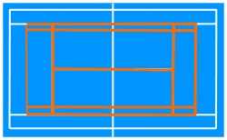
Balls: | Mini Orange 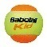
Rackets: | No larger than 25’’/26’’ Mini Rackets (For reference 27’’ is an adult racket)
Scoring: | - Each rubber is best of 3 tie-breaks (1st to 7 points: next point wins at 6-6)  - The first server serves one point from the right and then it is 2 points per player thereafter alternating points serving from the Left and Right.  - Players change ends at the end of each set to 7.
Serving: | - Serves are diagonal into the service box from behind the baseline.  - A player receives a 2nd serve in the event of the first serve being out or in the net. 2 errors is a double fault and a lost point.  - Serves can be over-arm or under-arm (There is no rule in tennis to say the serve must be over-arm, only that the ball must be played before it bounces.)  - A ‘let’ is played if the ball touches the net on the serves but lands in. (If this happens during a rally then play continues).
Placings for RR and final tables: | - 2pts for a team win, 1pt for a draw, 0pts for a loss.  - The team score is made up of the total number of rubbers won eg 3-1 = 2pts to nil, 2-2 = 1pt each.  - In the event of 2 teams having the same number of points in the RR final table then the head-to-head result is taken. If the head-to-head score was a draw then use sets count back and then points count back.  - In the event of 3 or more teams being equal then head-to-head results between those teams are taken into consideration.
Conceded matches: | - Where a team has a player(s) missing, a 7-0 7-0 score will be awarded to the opposition for each of the corresponding rubbers missed by that player(s).  - Where matches are started but not finished due to a player being injured then a concession is made to 7 to the opposing player from the point of injury. Eg 3-3 becomes 7-3, 7-0.
Sport organiser: | Gavin Sutcliffe – LTA – gavin.sutcliffe@lta.org.uk
Further information: | http://www.lta.org.uk/LTA-Mini-Tennis/Orange/Mini-Tennis-Orange/

Local Cluster events: Y3/4 Mini-Tennis Red.
NOTE: | Please also use these rules when delivering Y5 Local cluster events delivered on Badminton or Mini-Tennis Red courts.
Event: | Y3/4 Mini-Tennis Red
Age group(s): | Y3/4
Team & squad numbers: | 4x players per team – 2x boys (1&2) and 2x girls (3&4)
Qualification: | Discretion of SGO depending on the number of places at Partnership final
Format: | Round robin group format followed by play-offs (if needed) to determine final team positions.
Singles match order: | - Round 1: Singles 1v1, 2v2, 3v3, 4v4  - Round 2: Reverse Singles 1v2, 2v1, 3v4, 4v3  The reverse singles is subject to format eg A small RR of 3 to 4 teams for Y3/4 would benefit from reverse singles so each player would get 4-6 individual singles matches (4-8 matches for Red is the norm depending on facilities and time).
Seeding: | N/a
Suitable Courts: | Mini Red Courts on Indoor Tennis Hall or outdoor tennis court, or Badminton Courts in Sports Hall. (On a Badminton court the back tramlines are out)  
Balls: | Indoor: Mini Red Sponge Balls Outdoor: Mini Red felt 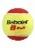
Rackets: | No larger than 23’’ Mini Rackets, 21’’ are fine.
Scoring: | - Each rubber is first to 10 points, next point wins at 9-9 (Match Tie-break)  - The first server serves one point from the right and then it is 2 points per player thereafter alternating points serving from the Left and Right.  - Players stay at the same end of the court for the entire match.  - Timed matches can be used as an alternative.
Serving: | - Serves are diagonal into the service box from behind the baseline.  - A player receives a 2nd serve in the event of the first serve being out or in the net. 2 errors is a double fault and a lost point.  - Serves can be over-arm or under-arm (There is no rule in tennis to say the serve must be over-arm, only that the ball must be played before it bounces.)  - A ‘let’ is played if the ball touches the net on the serves but lands in. (If this happens during a rally then play continues).  - At cluster events there may be beginner players who fine serving difficult. The organiser has the discretion to encourage a ‘bounce’ serve or taking a few steps forward if this helps facilitate play.
Placings for RR and final tables: | - 2pts for a team win, 1pt for a draw, 0pts for a loss.  - The team score is made up of the total number of rubbers won eg 5-3 = 2pts to nil, 4-4 = 1pt each.  - In the event of 2 teams having the same number of points in the RR final table then the head-to-head result is taken. If the head-to-head score was a draw then use sets count back and then points count back.  - In the event of 3 or more teams being equal then head-to-head results between those teams are taken into consideration.
Conceded matches: | - Where a team has a player(s) missing, a 10-0 score will be awarded to the opposition for each of the corresponding rubbers missed by that player(s).  - Where matches are started but not finished due to a player being injured then a concession is made to 10 to the opposing player from the point of injury. Eg 3-3 becomes 10-3.
Further information: | http://www.lta.org.uk/LTA-Mini-Tennis/Red/Mini-Tennis-Red/
Local Cluster events: Y5 Mini-Tennis Orange
NOTE: | Y5 events can be delivered indoors or outdoors. If delivering a Y5 event on Mini Red Tennis or Badminton courts then please use the Y3/4 Mini-Tennis Red rules sheet.  City Finals can be delivered as a Mini Red event (If facilities dictate) or a Mini Orange (If facilities are available to give players a chance to practice on an Orange court prior to the WYSG Finals)
Event: | Y5 Mini-Tennis Orange
Age group(s): | Y5
Team & squad numbers: | 4x players per team – 2x boys (1&2) and 2x girls (3&4)
Qualification: | Discretion of SGO depending on the number of places at Partnership final
Format: | Round robin group format followed by play-offs (if needed) to determine final team positions.
Singles match order: | - Round 1: Singles 1v1, 2v2, 3v3, 4v4  - Round 2: Reverse Singles 1v2, 2v1, 3v4, 4v3  The reverse singles is subject to format, no. of teams and courts available (4-6 matches for Orange is the norm for scoring to 7, best of 3 sets)
Seeding: | There should be no pre-seeding of teams for the group stage other than team optimisation (where possible) to avoid teams from the same area playing each other at the group stage.
Courts: | Outdoor Orange courts. (See alternatives for Y3/4 rules)
Balls: | Mini Orange 
Rackets: | No larger than 25’’/26’’ Mini Rackets (For reference 27’’ is an adult racket)
Scoring: | - Each rubber is best of 3 tie-breaks (1st to 7 points: next point wins at 6-6)  - The first server serves one point from the right and then it is 2 points per player thereafter alternating points serving from the Left and Right.  - Players change ends at the end of each set to 7.  - Timed matches / Tie breaks to 10 can be used as an alternative.
Serving: | - Serves are diagonal into the service box from behind the baseline.  - A player receives a 2nd serve in the event of the first serve being out or in the net. 2 errors is a double fault and a lost point.  - Serves can be over-arm or under-arm (There is no rule in tennis to say the serve must be over-arm, only that the ball must be played before it bounces.)  - A ‘let’ is played if the ball touches the net on the serves but lands in. (If this happens during a rally then play continues).
Placings for RR and final tables: | - 2pts for a team win, 1pt for a draw, 0pts for a loss.  - The team score is made up of the total number of rubbers won eg 3-1 = 2pts to nil, 2-2 = 1pt each.  - In the event of 2 teams having the same number of points in the RR final table then the head-to-head result is taken. If the head-to-head score was a draw then use sets count back and then points count back.  - In the event of 3 or more teams being equal then head-to-head results between those teams are taken into consideration.
Conceded matches: | - Where a team has a player(s) missing, a 7-0 7-0 score will be awarded to the opposition for each of the corresponding rubbers missed by that player(s).  - Where matches are started but not finished due to a player being injured then a concession is made to 7 to the opposing player from the point of injury. Eg 3-3 becomes 7-3, 7-0.
Further information: | http://www.lta.org.uk/LTA-Mini-Tennis/Orange/Mini-Tennis-Orange/

RUGBY
*Rugby League Tag

Pathway
SSP Competition Leeds Final West Yorkshire School Games
Qualifiers: The top four teams per SSP qualify through to the Leeds final.
Age Category
Year 5 and 6

- This is a 7 a-side game, comprising of a squad of 10 children. The squad will be mixed with at least four girls and at least two girls must be on the pitch at all times.
- The duration of the game will be two halves of 7 or 10 mins each.
- The game will be played with a size 4 rugby ball.
- When playing Tag Rugby all players must wear a “tag belt” that has two ribbons (tags) attached to Velcro. The belt must be worn around the waist with all loose clothing tucked in. The tags are positioned on either side of the hips with teams being distinguished by the colour of the tags they wear.
- The team in possession has the ball for a total of six tags (tackles).
- A try is scored the normal way by placing or touching the ball down on or over your opponents’ try line. NB players will not be allowed to dive over the try line in the act of scoring a try.
- Players must stay on their feet AT ALL TIMES (NO DIVING). This includes when making a tag, falling on a loose ball and scoring.
- Only the player in possession of the ball can be tagged. A tag is simply the removal by a defender of one of the two ribbons from the ball carrier. The ball carrier cannot fend off or guard (hand off) the tags in any way. When a defender has removed the tag, it should be held above their head and shout “TAG!” for all to hear.
- The player at Acting Half-Back cannot score a try from that position.
- The defensive line will be asked to retreat 5 metres.
- The ball carrier must stop and play the ball within 3 metres of the ‘tag’. If not, the referee will instruct the tagged player to return to the mark where tagged.
- The tagged player then plays the ball through his/her legs. After playing the ball, the tackler will give the tag back to the attacker who must replace it on his/her belt, before re-joining the game.
- Spinning with the ball to avoid being tagged in not allowed.
- All infringements will result in a handover to the non-offending side at the place the infringement occurred and play is restarted with a pass.
- There will be no kicks allowed including conversions.
- The game will commence with a pass, centre field at the beginning of each half.
- After a try has been scored the non-scoring team will restart with a pass at the half way line with the opposition back 7 metres.
- A try scores 4 points.

NB.
PLAY THE BALL SEQUENCE:
- DEFENDER REMOVES TAG, SHOUTS “TAG!” AND HOLDS THE TAG ABOVE THEIR HEAD (DO NOT THROW ON GROUND)
- BALL CARRIER STOPS, PLAYS THE BALL AND THEN RECEIVES THE TAG BACK FROM THE DEFENDER. HE/SHE REPLACES THE TAG BEFORE RE-JOINING THE GAME.

Further information

The Leeds Rhinos Foundation can create a Sport & PE package that is tailored to the needs of the school and will truly benefit the pupils. For more information see the link below or contact Gareth Cook.

http://www.leedsrhinosfoundation.org/sport/school-sport-offer.php

Email: Gareth.Cook@leedsrhinosfoundation.org

TRI GOLF
Pathway

LEEDS QR –Area Comps West Yorkshire School Games

Qualifiers: 5 Leeds Schools to West Yorkshire School Games
Age Category: KS2

Team requirements:
- Teams of 10 – 5 boys and 5 girls.
- Each team of 10 players will accumulate a score for each game and a total score for the festival. The team with the highest score wins the event.

Further Information:
http://www.golf-foundation.org/page.asp?section=280&sectionTitle=School+Games

Skills Festival layout for Levels 2 and 3 School Games
Basic Rules
- Participants will take part in 8 games (as below) and a bunker rest stop
- 2 tees per games station
- 5 pupils per tea
- Ensure a left hand chipper is placed on each chipping game
- 2 mins practice time and 5 mins scoring time on each game
Example of events below –these may vary with each competition:
- Dominoes

- Drive for show put for dough.

- Finders Keepers

- Grand National

- Tunnel Ball

- Zone Ball

- Down the middle

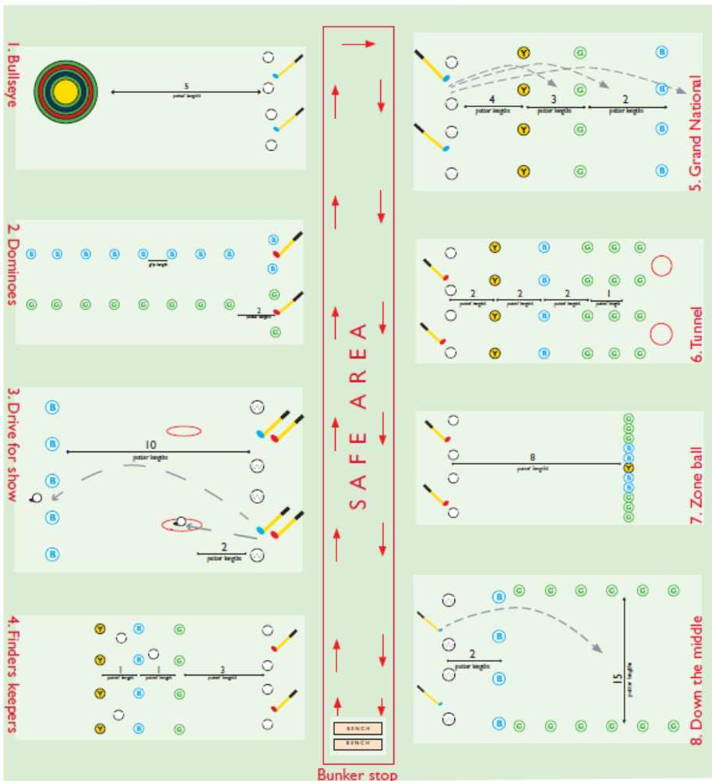

WAKE UP SHAKE UP

Pathway
SSP- ACTIVE SCHOOLS Qualifier Leeds Final

Qualifiers: One team from KS1 and one team from KS2 go through to the Leeds Final.
Age Category
Teams must be made up of pupils from key stage one or key stage 2.

The criteria for the festival will be as follows:

- Each school may enter a maximum of two teams
- This is not a dance contest, it is fitness routine designed to be delivered to other pupils
- All routines will involve a maximum of 10 pupils
- The 10 pupils involved can be from any year group & be mixed in any ratio within the Key Stage.
- The routine should be no longer than 3 minutes
- Each school should devise their own routine & to music of their choice
- All routines will be marked out of 5.
- No props will be allowed during the routine
- Each routine shall be judged on the following:
    - Creativity of routine ( /5)
    - Enthusiasm / Energy ( /5)
    - Interpretation of the music ( /5)
    - How FUN the routine is ( /5)
    - How well the group movement is synchronised ( /5)
    - How well it can be taught to other pupils ( /5)
    - Maximum score = 30

All pupils should be perform their routine in a school uniform or PE kit

Rules and Competition Format

Team Requirements

- Each team can consist of up to 10 children

- There will be separate KS1 and KS2 events

- Teams can be single sex or mixed sex and can be made up entirely from 1 year group or can be combined year groups (within the same key stage)

- Teams should wear their normal PE clothes – no sequins !

No props allowed

- Each team performs a ‘Wake Up Shake Up Routine’ to music, which is up to 3 minutes long.

- Routines should be devised so that if ever used they could easily be followed by a large number of pupils.

- The children performing must be involved in creating the routine to the music of their choice.

- Each routine shall be marked out of 5 and will be judged on each of the following criteria ~
    - Creativity of routine ( /5)
    - Enthusiasm / Energy ( /5)
    - Interpretation of the music ( /5)
    - How FUN the routine is ( /5)
    - How well the group movement is synchronised ( /5)
    - How well it can be taught to other pupils ( /5)
    - Maximum score = 30

Remember this is a Wake Up Shake Up Competition, and not a dance competition. It is a fitness routine designed to be delivered to other pupils.

HOCKEY
Quick Sticks
Pathway
Leeds Competition West Yorkshire School Games

Qualifiers: 4 from Leeds Competition to West Yorkshire School Games
Age Category: Years 5 & 6

Team requirements:
- Teams of 4 with maximum of 7 in squad
- No goalkeepers

Further Information: http://www.playquicksticks.co.uk/?cat_id=35&level=1
There are some great resources for schools to utilise in the run up to the competition.

Match Official:
A person who is deemed responsible (teacher, parent, coach) for a team shall be named as a ‘Match Official’. There shall be two Match Officials per game (one from each team).
Match Officials shall have a ‘duty of care’ for each participant and must supervise the game and assist the players and the umpires in creating an environment of fair play and safety.

The overall responsibility for the game is held by the two Match Officials.

Teams:
There are NO Goalkeepers in Quicksticks. A team consists of six players; four of which are on the field of play at any one time, with the remaining two team members encouraged to take on leadership roles such as umpiring and managing. It is suggested that the leadership roles are rotated among the team at the end of each playing period. In a competitive situation the gender balance within the teams should be adjusted to provide equitable standards of play.

Starting and Re-starting Quicksticks
Quicksticks starts with one team being given a centre pass (taken from the centre of the pitch) which can be passed in any direction, once the umpires have blown a whistle. A centre pass is also taken at the start of each period of the game, alternately by each team, and by the non-scoring team after a goal has been scored. The direction of play for teams is alternated at the start of each period of the game. When a centre pass is taken at the start or re-start of the game, each team must be positioned in their own half of the pitch and the opposing players must be a minimum of 3 metres from the ball until the ball is played.

Scoring a Goal
A goal is scored when the ball has been struck or deflected off a player’s stick (either an attacker’s or a defender’s) from within the shooting area (circle), and it crosses completely over the goal-line between the goalposts and under the cross-bar.

Free-pass
A free-pass is given when an offence occurs. For all free passes (a – l below) the ball must be taken from where the offence took place. Until the free-pass is taken, all players from the opposing team must be 3 metres away from the ball. After touching the ball, the free-pass taker cannot touch the ball again, until it has been touched or played by another player. If the free-pass taker touches the ball twice the other side get a free-pass. If an offence is committed within 5 metres of the goal line (or within the shooting circle if a circle is being used), the free pass should be taken 5 metres away from the goal line (or from outside the shooting circle).

A free-pass is awarded when:
a] The ball passes completely over a side line. The free-pass should be taken by a player of the team which did not touch the ball last, and it must be played along the ground in any direction (on the pitch), from the point where the ball went off the pitch (i.e. where it crossed the side line).
b] The ball passes completely over the back line and was last touched by an attacker. The free-pass should be taken by the defending team, from the top of the shooting circle in their third, in line with the centre spot. All players from the attacking team must retreat to their defending third of the pitch.
c] The ball passes completely over the back line and was last touched by a defender. The free-pass shall be taken by the attacking team from the corner of the pitch nearest to where the ball crossed the line (this case is similar to a corner ball in football).

And where a player:
d] Kicks*, propels, picks up, throws, or carries the ball (*Note: It is not an offence if the ball touches a player’s foot and the whistle should only be blown if the incident breaks down play or creates a disadvantage. The umpires must be the judge.)
e] Intentionally uses any part of their body to play the ball
f] Attempts to play at any high ball (over knee height) with the stick
g] Uses the rounded (back) side of the stick
h] Whilst striking the ball, causes any actual or possible danger to themselves or to other players
i] ‘Obstructs’ by running between the ball and an opponent who is close enough to hit it, thereby unfairly preventing the opponent from playing the ball. Players must not use any part of their body or stick to obstruct another player
j] Holds, charges, kicks, pushes, intentionally trips or strikes any player or umpire
k] Interferes with another player’s stick or clothing
l] Plays the ball dangerously or in a way which leads to dangerous play. Rough or dangerous play will not be allowed, nor will any behaviour that, in the opinion of the umpires, amounts to
misconduct.* (*Note: The overall Match Officials shall send any player who persists in breaking this rule off the pitch for a two-minute suspension in the sin bin. For the duration of a temporary suspension, the offending team plays with one player less.)
A penalty goal will be awarded if a defending player deliberately stops a ball from crossing the goal-line with their feet or body.
ROUNDERS

PATHWAY: There is no pathway for this event.

RULES: The rules to be followed are from Rounders England. Click on this link for the full rules http://roundersengland.s3.amazonaws.com/2013/03/Simplified-Rules-Colour.pdf

AGE CATEGORY: Years 5 & 6

Rounders is played between two teams and the aim of the game is to score the most Rounders.

The very basic rules are:

- Teams can be a minimum of 6 players and a maximum of 15 players. 9 players are on the field for each team at any one time.

- If a mixed team – there should be no more than 5 male players.

- One team bats while the other team fields and bowls.

- The bowler bowls the ball to the batter who hits the ball anywhere on the Rounders pitch. The batter then runs to as many posts as possible before the fielders return the ball to touch the post the batter is heading for.

- If the batter reaches the 2nd or 3rd post in one hit, the batting team scores ½ Rounder. If the batter reaches 4th post in one hit, the batting team scores a Rounder.

- A batter can be out if the fielding team catch the ball hit by the batter before it touches the ground or by touching the post the batter is heading to with the ball before the batter reaches it.

